Business Correspondence – Memo Assignment
Rachit Bhatt – C0902810
Artificial Intelligence and Machine Learning (Section 2), Lambton College in Toronto
COM 3013 2 [Online 8] Professional Communications
Prof. Rehab Alsayad
November 24, 2023

To: | All Employees
From: | Rachit Bhatt, IT Director
Date: | 23 November 2023
Subject: | Strengthening Measures of Email Security and Phishing Awareness.

Summary:
Implementation of new security measures to protect our sub rosa information as a response to a rise in the threat of malicious emails in an attempt to steal our confidential data. In this memo, the abstraction of the recent changes in our email policies, providing a spotlight on the benefits, and delivering guidance on recognizing and reporting phishing attempts are discussed.

Phishing Attack Problem:
Recently, our organization has been surged with malicious emails impersonating internal departments like executive management and human resources. Such emails target defrauding employees into revealing their login credentials, risking the clients’ data security significantly. Understanding the criticality of the situation, after consulting with the executive team and the IT department, the decision has been made to implement some enhancements to our email security measures.
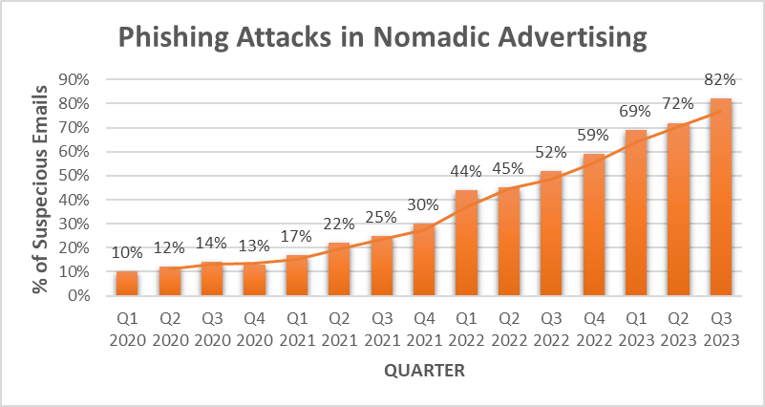
Figure 1. Phishing attacks in through emails in 2020-23

Change in Email Policies:
- Authentication using 2-Step: Not only this provides an additional layer of security which helps preventing the unauthorized access but also enhances the overall protection of our communications. Therefore, in order to work with their emails, all the employees are required to register for the 2-step authentication.
- Labeling Emails as “External”: Any email sources arriving outside the intendance of business will now be labeled automatically with “External” in its subject line, helping the employees to spot emails that require extra caution. Also, reduces the risk of being a victim of phishing attempts.

Requirement for Changing the Password:
Even though this might seem inconvenient, in order to defend our business and secure against potential breaches, it is a vital step for our organization. Updating the password regularly helps to reduce the risk of compromising the account. So, all of the employees are now required to change their email password every 6 months to not lose the access.
Benefits:
- Better Security: Protects client data and sensitive information from unauthorized access.
- Improved Categorization: Identifying external emails clearly which enables extra caution as an exercise.
- Proactive Defense: Frequently changing the passwords strengthens our overall security.

Recognizing the Phishing Attempts:
Please note the following indicators to prevent being victim of the phishing attempt:
- Check Sender’s Details: Verify their email address and be careful of variations and misspellings indicating a fraudulent sender.
- Inspect Email Content: Look for urgency in their requests and unusualness in the language like grammar. The internal communications are typically written professionally and are verifiable.
- Validating Links: Before clicking on any links posted in the email, hover your mouse over all of them to preview their destination. Avoid clicking on the unexpected or suspicious links.
- Authenticate Unfamiliar Requests: Have extra caution on emails requesting sensitive information, such as financial or login details. Validate them using alternative communication channels before responding.

Reporting Suspected Phishing Attempts:
Please forward the email to the IT department immediately at itteam@nomadicadvertising.com in case of any suspiciousness or phishing attempt without any delay. Your instance action is crucial for identifying and handling potential threats.

Thank you for understanding and your cooperation in considering the importance and criticality of cyber threats and collaborating collectively to strengthen the defenses of our organization.

